Name Areeba Saleem

Roll number 2k21/MKIT/03

2nd Assignment of Python Programming

Given by Muhammad Hanif

Task 1.

city = {6900: 'Mirpurkhas', 74000: 'Karachi', 17000: 'Hyderabad', 546370: 'lahore'}

city = [6900]

Output

'Mirpurkhas'

Snapshot

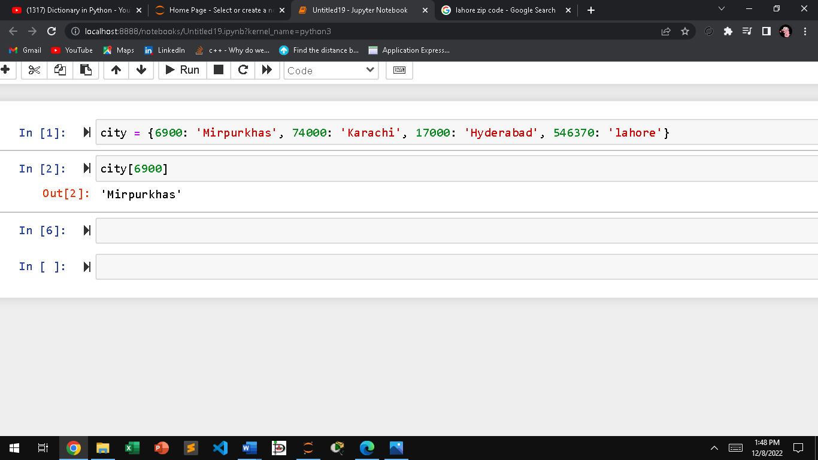

Task 2.

students = dict()

n = int(input("How many students are there : "))

for i in range(n):

sname = input("Enter name of the student: ")

marks = []

for j in range(5):

mark = int(input("Enter the marks:"))

marks.append(mark)

students[sname] = marks

print ("created dictionary of student is",students)

total = mark

print ("Total Score:" ,total)

percentage = (total/2500)\*100

print("Percentage:", percentage, "%")

Snapshot

